Magnus skin 4 months and 7 days
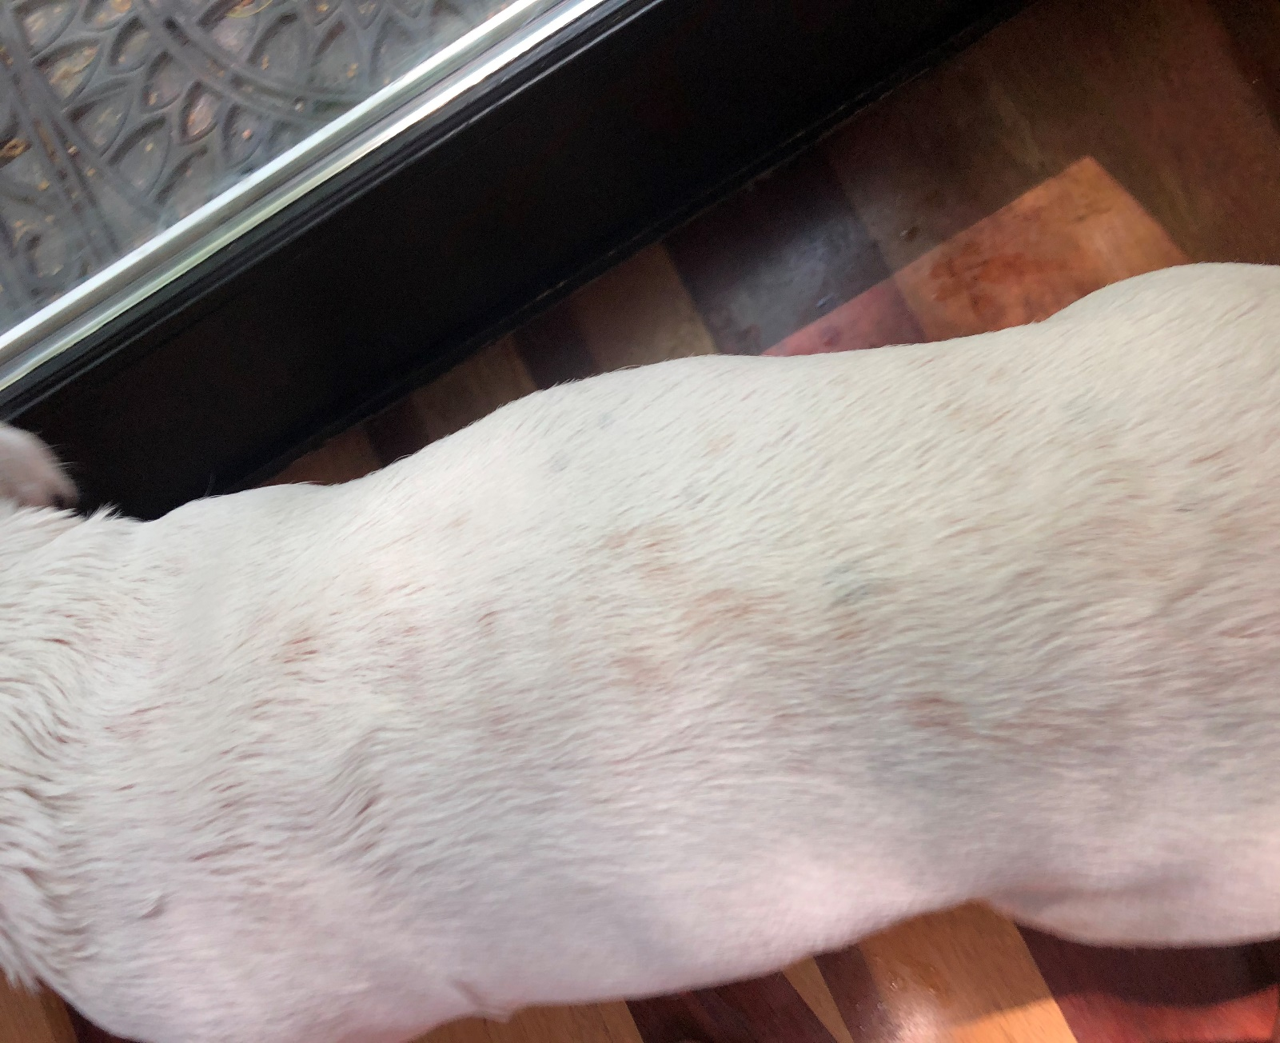

Magnus skin at 8 months and 7 days

